Desktop Pulsating Vacuum Sterilizer
PICTURE | MODEL: | SQ-T80B
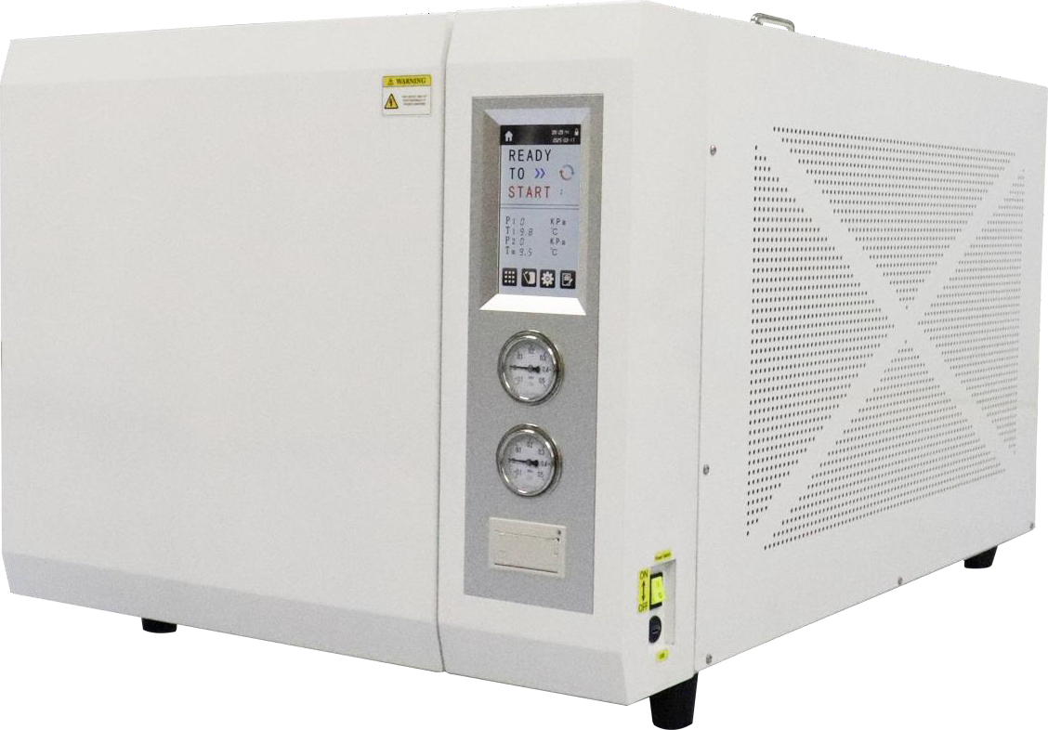 | CAPACITY: | 80L
 | CHAMBER SIZE: | Φ391*671mm
 | DIMENSION: | 1140*804*695mm
 | NET WEIGHT: | 193KG
 | POWER: | 6.2KVA
 | VOLTAGE: | AC 220V/50Hz
 | STERILE TEMP: | 121 ℃ /134 ℃
 | STERILE TIME: | 15MIN-60MIN
ΤΙΜΟΚΑΤΑΛΟΓΟΣ  ΠΡΟΣΦΟΡΑ | EURO 6,900  EURO 6,100

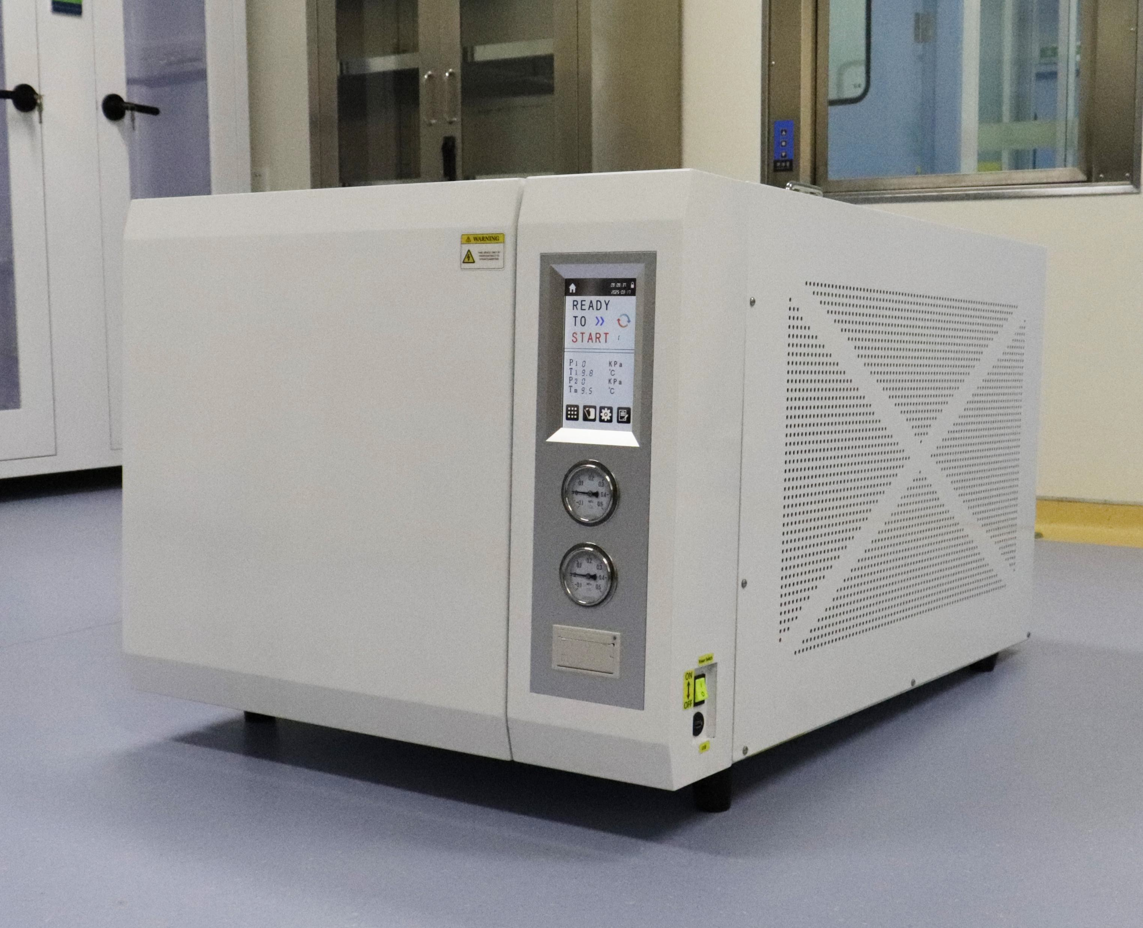

NO. | SQ-T80B Desktop pulsating vacuum sterilizer
1 | main body
1.1 | Volume: 80 L
1.2 | Material: 06Cr19Ni10 stainless steel
1.3 | Design pressure: -0.1 / 0.3 Mpa
1.4 | Design temperature: 150℃
1.5 | Sterization temperature selection range: 105℃ -134℃
1.6 | Rated working temperature: 121℃ / 134℃
1.7 | Service life: 8 years
1.8 | Main body insulation: 10mm glass wool
1.9 | Lumen wall heating: film-coated cavity wall heating film
2 | Seal door
2.1 | Door panel: stretch door panel, material thickness of 2.5mm
2.2 | Material: 06Cr19Ni10 stainless steel
2.3 | Open and close the door mode: automatic quick door opening
2.4 | Safety interlock: If the door of pressure safety interlock, the power can  be connected to heat and generate steam; there is pressure in the inner chamber and the door cannot be open.
2.5 | Door sealing method: self-expansion sealing ring, using transparent  medical silicone rubber molding
2.6 | Door cover: cold plate spray plastic shell, effectively prevent scald
3 | pipe system
3.1 | Control valves: 5 direct-action solenoid valves, and 3 manual ball  valves
3.2 | Steam generation mode: built-in energy storage steam generator,  steam generator, steam generation speed is fast, high quality

3.3 | Water injection and drainage method: automatic water injection, automatic drainage
3.4 | Water storage device: built-in open water tank, steam water internal  circulation, water tank capacity of 14 L
3.5 | Pressure gauge: range: -0.1~0.5MPa Precision level: level 1.6
3.6 | Removable filter: manual removable filter, easy to clean, more  humanized
4 | navar
4.1 | Control mode: SCM control
4.2 | Interface display: the LCD touch screen can display the temperature, pressure, time, running state, fault alarm and equipment running curve and other information in real time, which makes the sterilization information more intuitive and convenient for users to observe the  running state of the equipment
4.3 | Process control: preheating, replacement, heating, sterilization, steam exhaust, vacuum drying process automatic operation; it is steam as the medium, using efficient vacuum system, repeated vacuum, to achieve  the effect of sterilization and drying
4.4 | Multi-point temperature control technology: non-airtight liquid program uses mobile temperature sensor to measure the temperature, which can detect the internal temperature of the liquid, the liquid  internal temperature is more intuitive and clear
4.5 | Thermal insulation function: the insulation function can be set according to the need to realize liquid culture medium sterilization,  medium dissolution-insulation function
4.6 | Safety protection: with overtemperature automatic protection device, anti-dry burning protection device, overpressure automatic discharge  device, over-current protection device, electronic circuit safety device
4.7 | Self-calibration function: it has a complete background self-calibration system to realize the calibration of pressure, temperature and other system parameters. Without splitting the instrument, the permission  tool can be used for on-site adjustment
4.8 | Independent installation of pressure sensor: an independent pressure transmitter is installed in the inner chamber and the evaporator to  ensure that the equipment pressure is within the safety control range
5 | software
5.1 | Program name: bare procedures, encapsulation procedures, rubber  procedures, dressing procedures, liquid procedures, liquid customization, solid customization, medium sterilization, medium

 | dissolution and other procedures, as well as B & D testing and vacuum testing procedures
5.2 | Scope of application: Non-liquid procedures are suitable for sterilization of surgical instruments, solid bare instruments, packaging instruments, rubber loads, etc., and liquid procedures are suitable for  sterilization of water, culture media and other liquids
6 | Overall parameters
6.1 | Loading device: one 304 pallet frame and three pallets
6.2 | Equipment power supply: single-phase: AC220V, 50Hz
6.3 | Equipment power: 6.2kW
6.4 | Chamber dimensions (mm) (Φ×L): Φ 391 * 671
6.5 | Overall dimension (mm) (L×W×H): 1150 * 806 * 680
6.6 | Packaging size (mm) (L×W×H): 1270 * 870 * 830
6.7 | Net weight (kg): 193 gross weight (kg): 220

