Veterinary Diagnostic Ultrasound System

Vetus 5

Expand your vision
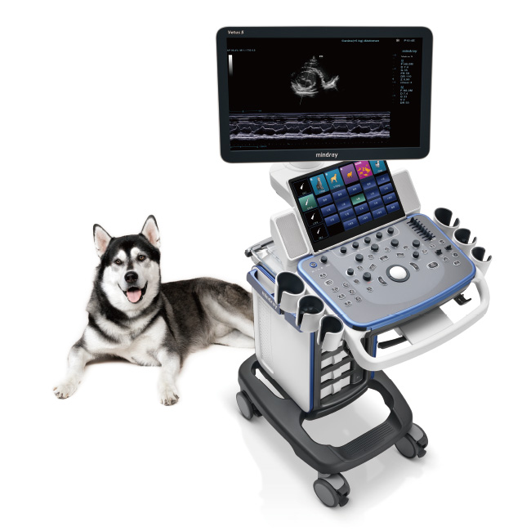

Overview
Vetus 5 offers the cost-effective veterinary ultrasound imaging system with multiple intelligent functions. Configured with Mindray brand new VETUS platform,, making it easily meet the increasingly diversified veterinarian demands.

Dedicated Animal Presets
- Professional ultrasound image presets according to different animals’ body characteristics
- Animal species are subdivided to different categories by weight and body size for precise diagnosis
- Veterinary recognized measurement formula presets, easily user-defined modification
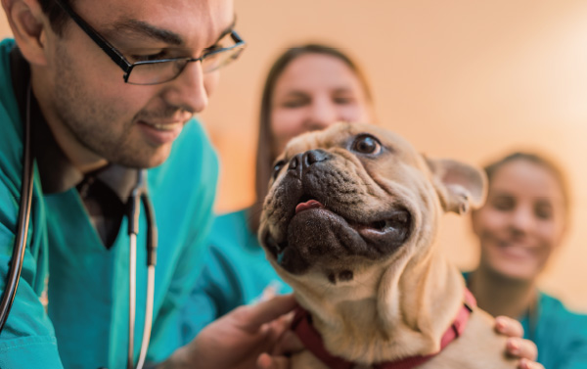

Simple Veterinary Workflow
- Transducers and the corresponding exam modes are displayed in the same interface, select or switch within 1 second
- Recent 4 modes are presented at hand, one-key to switch the frequently-used exam mode
- Super smart touch screen supports powerful multi-touch fast operation
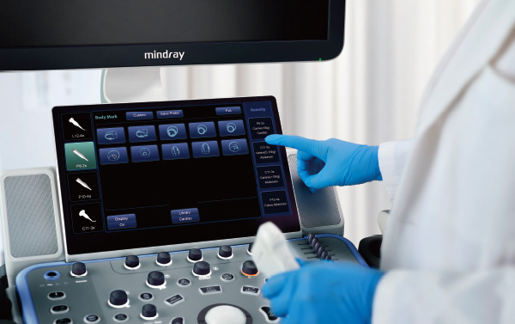

Advanced Ultrasound Technology
ComboWave transducers integrated with Mindray''''s unique 3T technology, allowing you to experience outstanding performance with extreme image resolution and uniformity in animal abdomen, small parts, reproduction and more.
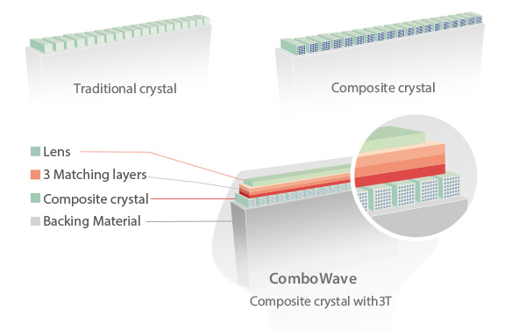

Powerful Intelligent Tools

iTouch
iTouch is a one-button auto image optimization solution, which is able to optimize the imaging quality automatically, including in B/PW mode.
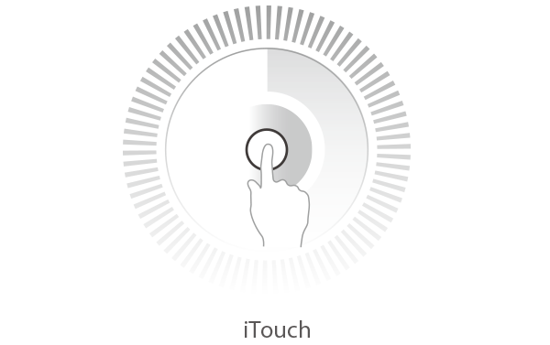

Professional Application Packages

Animal abdomen solutions:
- iScape real-time panoramic imaging
- iNeedle for biopsy needle enhancement
- Elastography Imaging
- UWN Contrast Imaging
- Smart Bladder for automatic volume calculation

Animal cardiac solutions：
- CW/PW automatic tracking & analysis
- Free Xros M for anatomical M mode
- Free Xros CM for curved anatomical M mode
- Tissue Doppler Imaging (supporting 4 modes)
- Tissue Doppler Imaging with Quantitative Analysis

Clinical Images

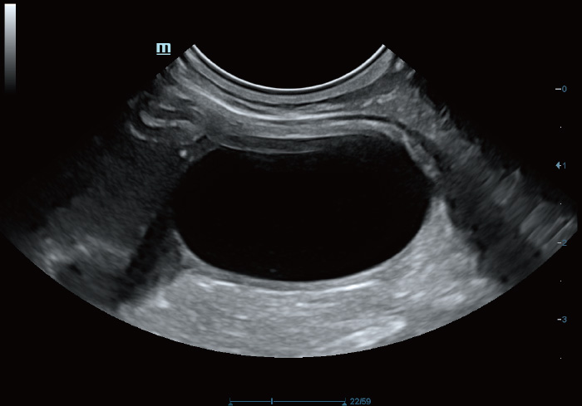

Canine Bladder

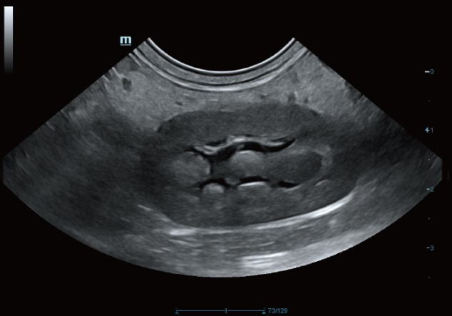

Canine Kidney

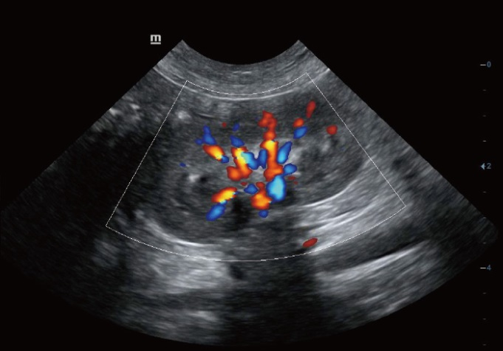

Color Mode of Canine Kidney

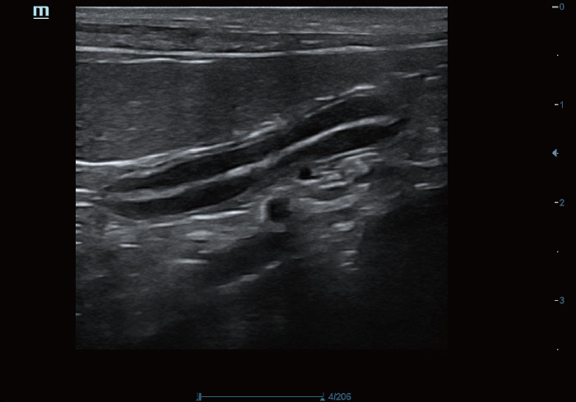

Feline Abdomen

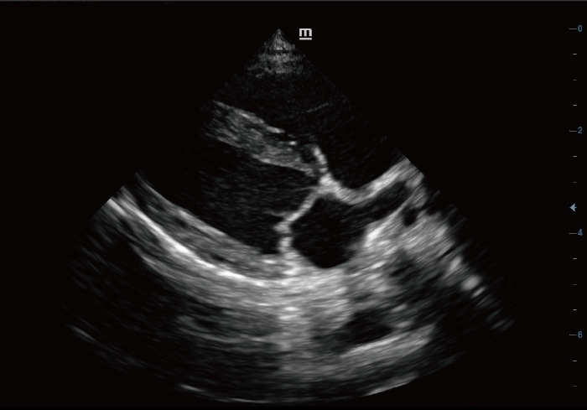

Long Axis View of Canine Heart

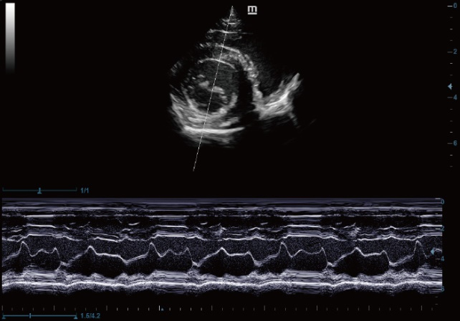

M Mode of Canine Heart

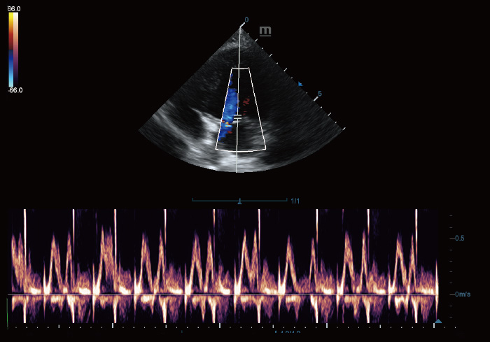

PW Mode of Canine Heart

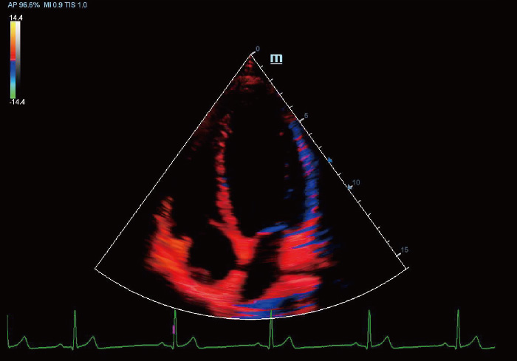

TDI of Canine Heart

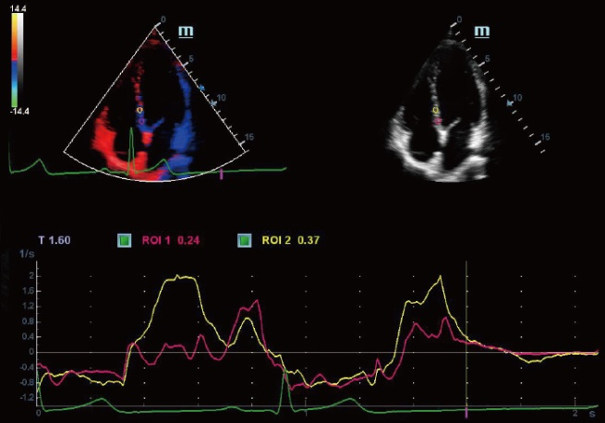

TDI QA of Canine Heart

